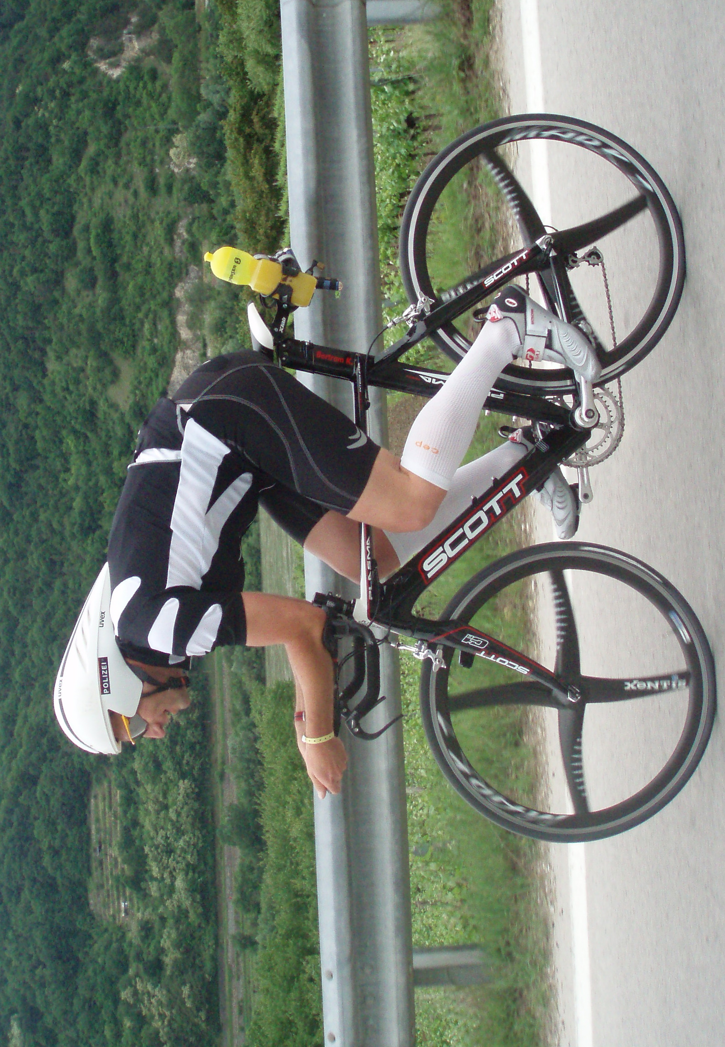
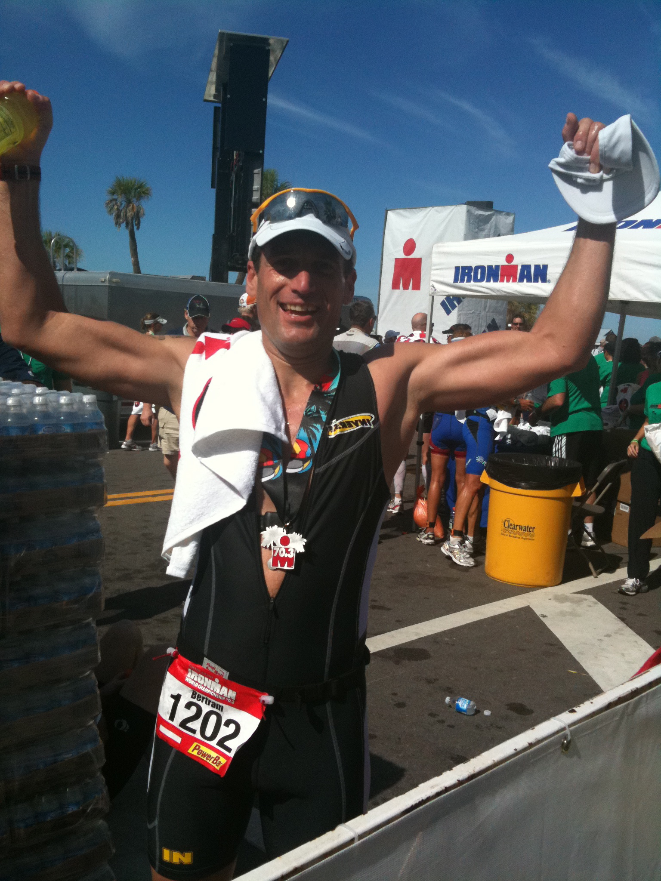
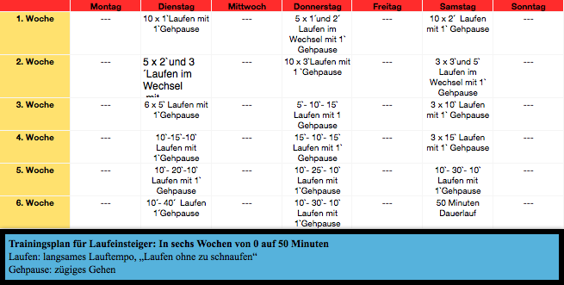
Training by Kieln

Tränkeweg 5, A 6799 Bludenz/Austria, TelNr: 0699 / 19074098
Mail: bertramk9@googlemail.com Web: http://web.me.com/bertramk/

